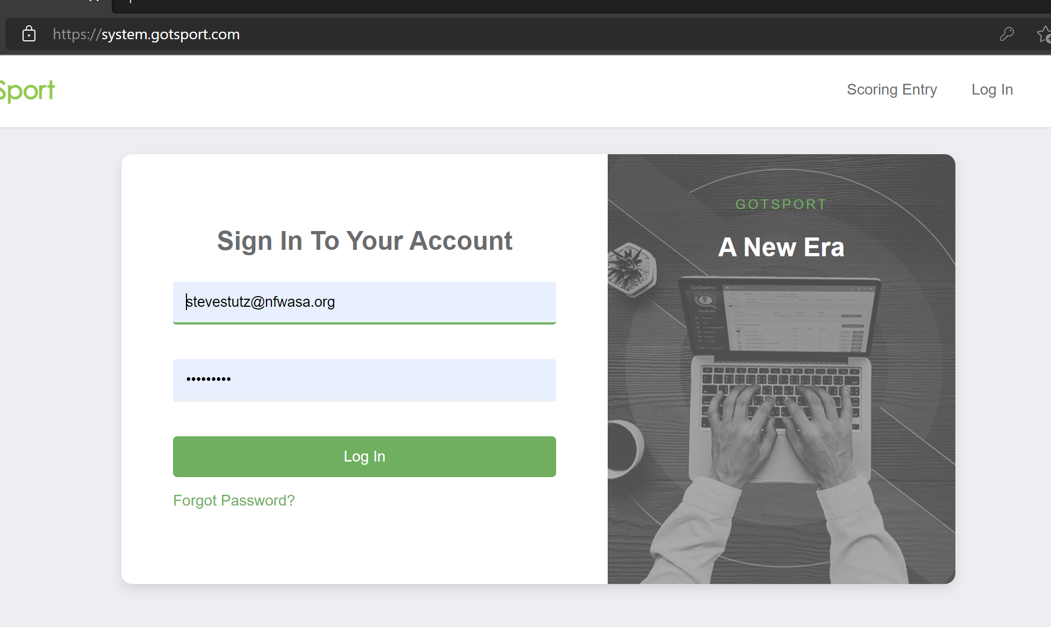
Login, then click on the person icon top right corner
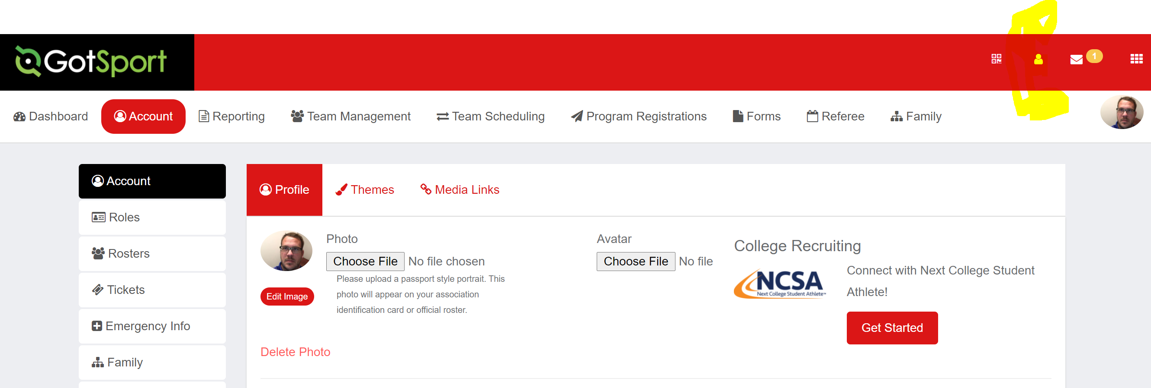

Once you click on the person icon, select profile
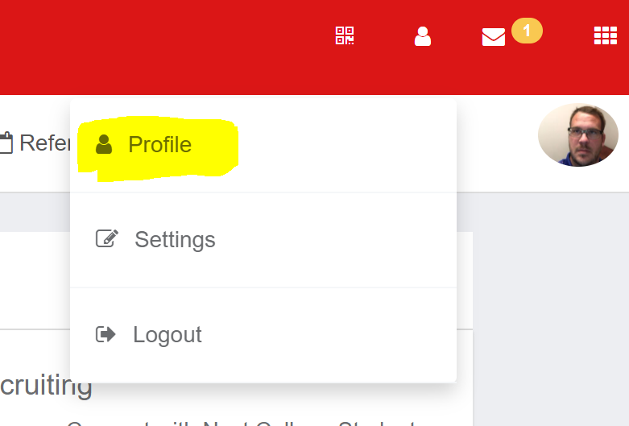

This is the screen that pops up… If you do not see this page, you may have to click on View Full Profile located on the right hand side of the below screenshot
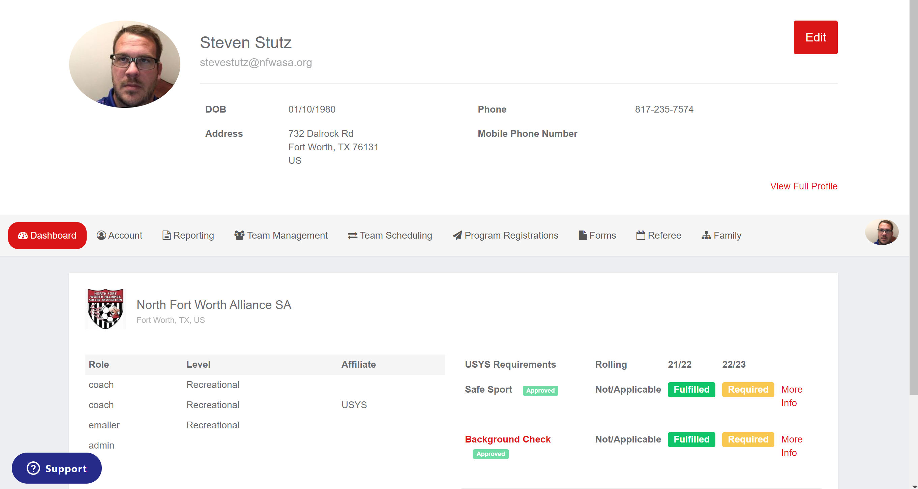

You should then be able to click on “More Infor”
