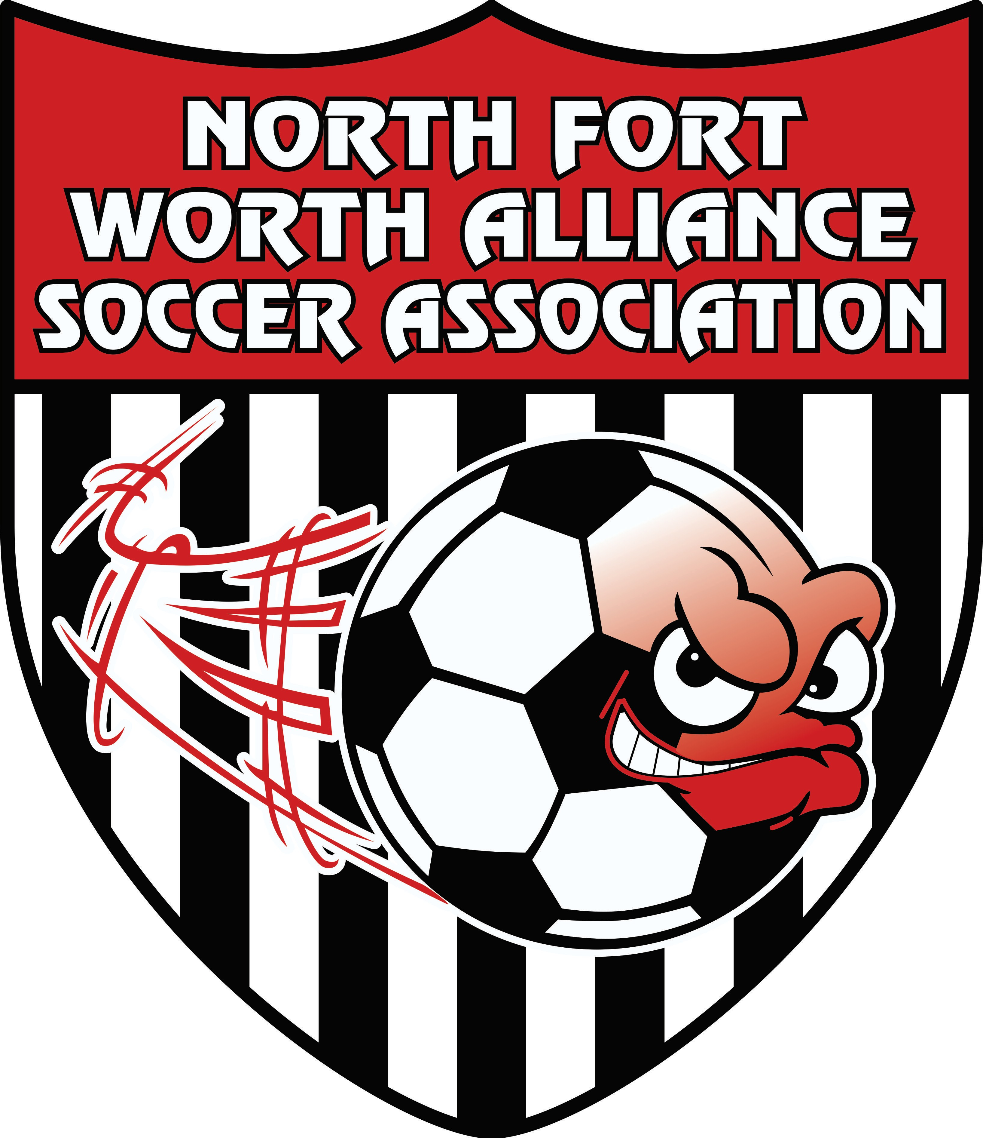
Coaching 101

Game Day
  - Coach Badge: Will be distributed prior to the beginning of the season. Must be worn and displayed during all NMCSL games. Badges indicate that a Background Check, Safe Sport, and CDC have all been completed
  - Game Ball: When playing at home you are required to furnish a properly inflated and maintained ball for game play.
  - Uniforms: Uniform design and color selections are determined at the beginning of each new Soccer year (Fall – Spring). All players will receive a new uniform at the start of each Soccer year to be worn for both seasons. A catch-up order will be done for newly added players ahead of each Spring season. Uniforms are typically passed out to each Head Coach the week of heading in to the first game.
  - Game schedules are typically released one week prior to Opening Day.
  - Weather: Game Cancellations. Social Media and Websites are usually the first to be notified. You are responsible for checking on your away fields through those same methods with that particular association.
Coaches Responsibilities
  - Keep your player’s safe
    - Enforce the background check process for team assistants
    - Zero Tolerance policy – be an example for our children (parents too!)
    - Shin guards must be worn to all practices and games
    - Emphasize hydration – water
    - Player Safety Online Training – GotSoccer Available now. Two required trainings CDC & SafeSport
  - Reporting scores for U9 and above – Call within 24 hours to report (Win or lose)
  - Tracking your misconduct and sit out verification (see your GotSoccer schedule too)
  - Finish the season and fulfill the commitment to your players
  - Have an assistant (other than your spouse) that can fill in for you in case of scheduling conflicts /other circumstances (relocations, etc.)
  - Keep us informed –
    - Send an email or catch one of us to report concerns; don’t assume we know
    - Send pictures to share on Facebook or Website to celebrate fun happenings
    - What else do you need from us?
  - Team Expectations
    - Player
      - Be Clear
      - Be Firm
      - Be Constructive
      - Don’t listen to parents on sidelines
    - Parents
      - Player performance – Keep parents informed
      - Parent cheering, not coaching
    - Coach
      - Your vision
      - Your philosophy
      - Your rules
  - Coaching
    - Practice
      - Be prepared
      - PLAY – practice – PLAY format
      - Little or no lines at practice
      - Situational/game like drills
      - Make it fun!
    - Games
      - Warm up
        - Coaches and players arrive early
        - Small sided games and touches to warm up
        - Static Stretching can be done after game – not before
      - Handling a defeat
        - Coaching moment
        - Players are resilient
      - Handling less skill teams
        - Incorporate rules to challenge players
        - Not doing justice to your player’s development
      - Behavior on Sidelines
        - Talk to referee before the game to clarify rules – substitutes, free kicks, etc. Also if needed talk to referee @ halftime away from players to discuss rules
        - Don’t engage with other coach
        - Keep emotions in check – Players are watching
        - Body Language
        - Positive Coaching
        - Constructive criticism to players

