Entering your Game Scores into GotSport

Go to the event schedule, located at https://system.gotsport.com/org_event/events/13587 OR
Schedules - NORTH FORT WORTH ALLIANCE SOCCER ASSOCIATION (nfwasa.org)

On the top right of the screen, you will see Scoring Input, click that
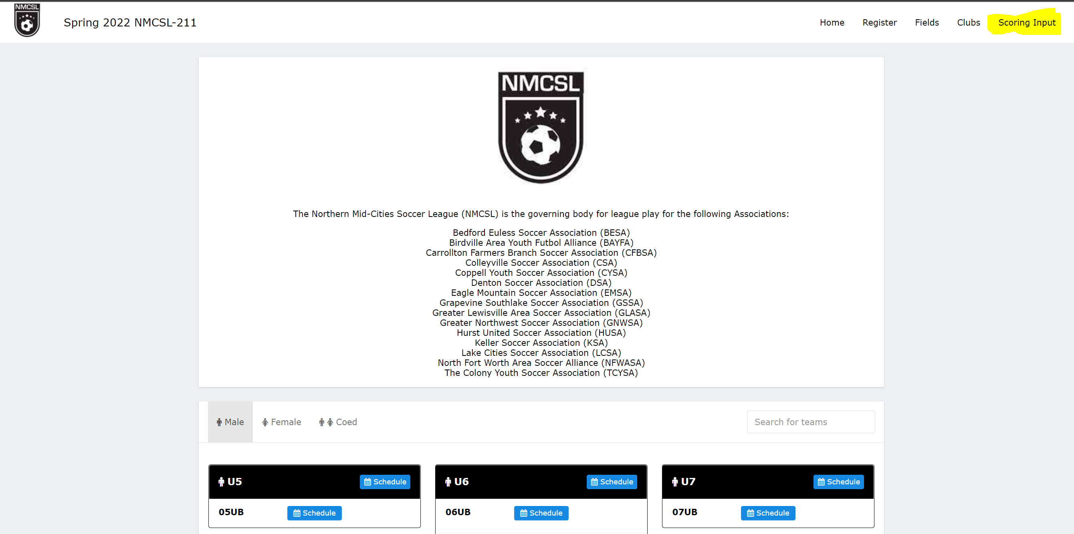

Enter the Pin: 4625
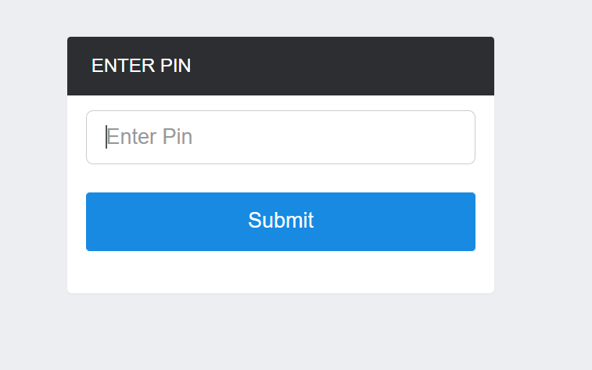

Search for your game #, then when the game pops up you can enter scores and save
