Player ID Cards and Official Rosters (Normally a Requirement for Tournament play)
Player ID Cards: For U13+ age groups and older the NMCSL is requiring that coaches either have a hard or virtual copy on hand for each of your regular season matches. You will need to first get with your team, and ensure that they upload a current photo of themselves where their face is clearly visible (MugShot), on their personal player profiles.
Official North Texas Roster: You now have access through your Coach profile to pull, save, and/or print your official roster signed by the NFWASA Registrar. This document is normally a requirement for the Checkin process for any additional tournaments your team might participate.
Both of these items are accessed through the same navigation.
Login to your Coach Profile and then Click on Team Management.
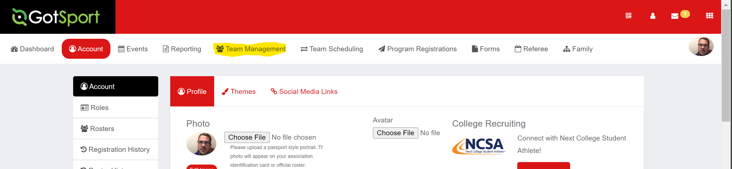

You will then click on the hyper link behind your team’s name.
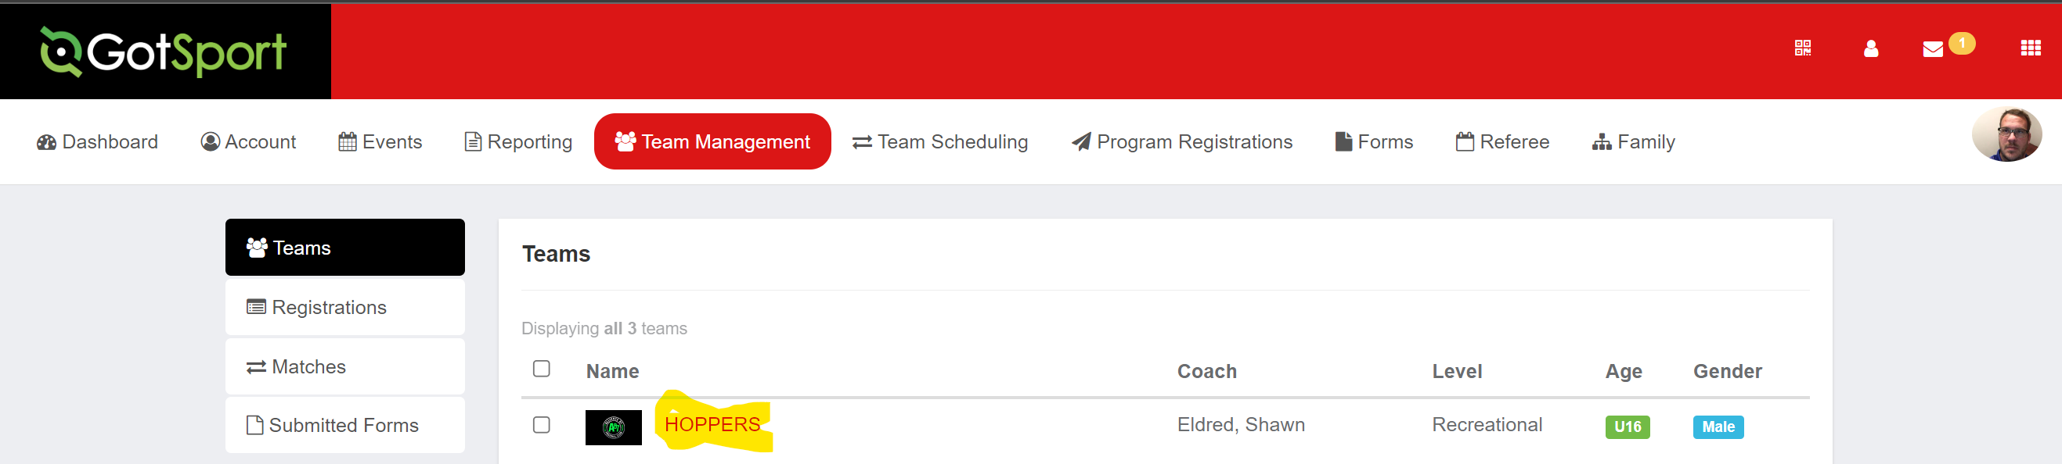
Next click on Rosters.
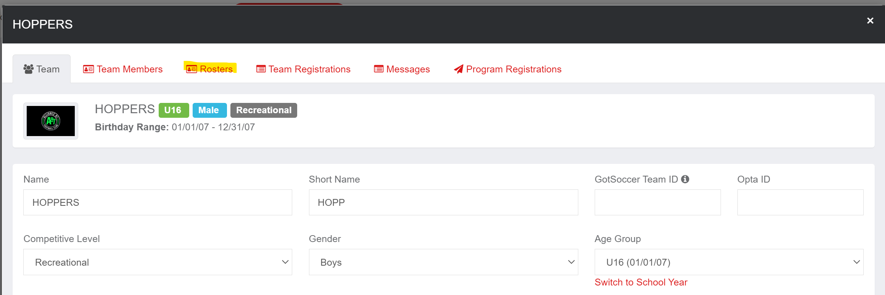

Select Event Roster for the current event, and hit Search
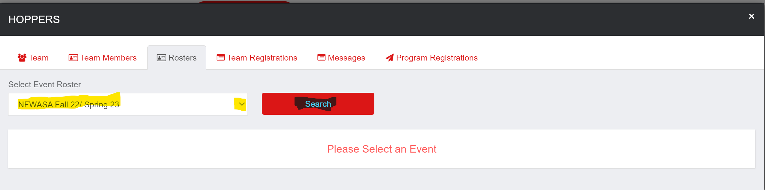

Once the Roster pops up, you should see a link for Documents and ID’s
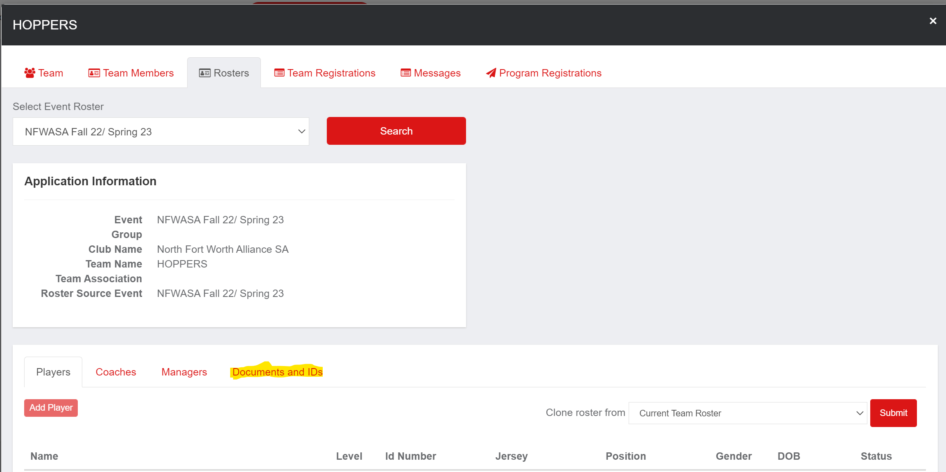

Finally, you should now be able to see two options. One for Player ID’s and one for the Official Roster.

